|  |  |
| --- | --- |
| Date | 15 November 2022 |
| Team ID | PNT2022TMID1633 |
| Project Name | Smart Fashion Recommendation Application |

Creation of Chatbot:

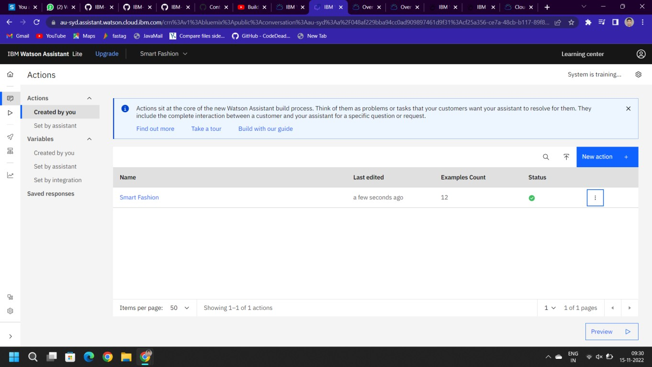

Integration of Chatbot with HTML web page:

